**Customizable Email Templates**

*Announcement Template—Monthly Discussion*

[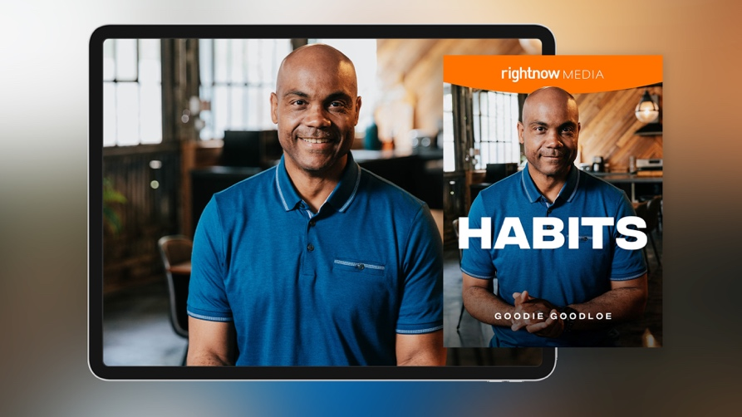](https://app.rightnowmedia.org/en/content/details/808822)

Team,

This month we’ll spend time as a team going through [*Habits*](https://app.rightnowmedia.org/en/content/details/808822)with bestselling author Goodie Goodloe on RightNow Media @ Work. I chose this series to help us learn how we can establish habits that help us thrive relationally, spiritually, and emotionally.

Over the next month, please find time to watch this six-session series on your own. In addition to watching the series, note your answers the below questions. We may not discuss every question, but I would like each person to be prepared to give your input if asked.

* [REVIEW QUESTION BANK AND INCLUDE 5-6 QUESTIONS HERE]

Please complete everything prior to [DATE], which is when we will discuss this series in our team meeting. If you haven’t registered your free RightNow Media @ Work account yet, here’s the link to do so: [INSERT CUSTOM LINK—LOG IN TO YOUR ACCOUNT, CLICK ‘CONTACTS’ IN TOP RIGHT, THEN CLICK ‘COPY INVITE LINK’ BUTTON. CONTACT YOUR CONSULTANT FOR ADDITIONAL HELP OR QUESTIONS.]

Let me know if you have any questions. I look forward to discussing this series together.

*Announcement Template—Weekly Discussion*

](https://app.rightnowmedia.org/en/content/details/808822)

Team,

This month we’ll spend time as a team going through [*Habits*](https://app.rightnowmedia.org/en/content/details/808822)with bestselling author Goodie Goodloe on RightNow Media @ Work. I chose this series to help us learn how we can establish habits that help us thrive relationally, spiritually, and emotionally.

Each week you’ll watch two sessions from the series and make note of your answers to the questions for that session (provided via email). We’ll then get together each week to discuss those sessions and the team’s responses. For our first discussion on [DATE], consider these questions as you’re watching sessions 1 and 2:

* [REVIEW QUESTION BANK FOR SESSIONS 1 & 2 AND INCLUDE TWO QUESTIONS HERE.]

If you haven’t registered your free RightNow Media @ Work account yet, here’s the link to do so: [INSERT CUSTOM LINK—LOG IN TO YOUR ACCOUNT, CLICK ‘CONTACTS’ IN TOP RIGHT, THEN CLICK ‘COPY INVITE LINK’ BUTTON. CONTACT YOUR CONSULTANT FOR ADDITIONAL HELP OR QUESTIONS.]

Let me know if you have any questions. I look forward to discussing this series together.

*Reminder Template*

*Tip: You can reply all to your previous announcement email so your team has easy access to the questions you sent over in the original email.*

Team,

Just a reminder that we’ll be discussing the [*Habits*](https://app.rightnowmedia.org/en/content/details/808822)series with Goodie Goodloe at our team meeting [next week / tomorrow].

* Make sure you’ve signed up for your free RightNow Media @ Work account: [INSERT CUSTOM LINK]
* Watch [the series here](https://app.rightnowmedia.org/en/content/details/808822) (available on desktop, mobile, or TV streaming devices).
* Answer the questions I previously sent over in preparation for our discussion.

Let me know if you have any questions. I look forward to discussing this series together.

*Weekly Question Email Template*

Team,

For next week’s discussion, watch sessions [X and X] of the [*Habits*](https://app.rightnowmedia.org/en/content/details/808822)series with Goodie Goodloe. Consider these questions as you’re watching:

* [REVIEW QUESTION BANK FOR THIS SPECIFIC SESSION AND INCLUDE 2-4 QUESTIONS HERE.]

Let me know if you have any questions. I look forward to discussing this series together.

**Question Bank**

*From session 1:*

* We tend to associate habits with things that are bad, like biting our fingernails, scrolling through too much social media, or eating too much junk food. But Goodie pointed out that we have good habits as well. **What are some of the positive habits you practice? How have these habits benefitted you?**
* Many people overlook the idea of fun in work. We tend to think of fun as a distraction from “real work.” But fun releases serotonin and dopamine into our brains, making us more efficient at building habits and healthy rhythms. **What would it look like to bring fun into your work? What concerns, if any, do you have with trying to prioritize fun in your busy schedule?**
* Goodie taught us that a good way to prioritize fun is to remain in the present. Yesterday is gone, and tomorrow isn’t promised. Having fun may force us to be more spontaneous, hold our plans more loosely, or be more willing to try new things. The habit of fun pushes us to make the most of each day. **Would you say that you are a present person?** **Why or why not?**
* Goodie ended the session by encouraging us to escape the mundane—to live outside of the nine-to-five realm. When we prioritize fun and play, we will find a more rewarding, exciting, and innovative work experience. **Describe a mundane day at work. What could it look like to shake up that normal schedule or make it more fun? What new rhythms or reminders could help you incorporate more play into your workday?**

*From session 2:*

* It is difficult to know a person’s motivations, so we are often left to assume why they make decisions. Sadly, that often leads us to think people are worse than they are. **Think of a recent situation when you wondered why a person acted the way they did. What did you assume about their intentions or thoughts?**
* We learned in this session that there are two consequences when we fail to assume the best in others. The first is that it makes us reluctant to create a future with others. Writing people off or reducing them to our expectations damages existing relationships and short circuits potential relationships—both those in work and our personal lives. **What does it look like when a person begins to expect the worst in others? How does it damage healthy relationships?**
* Goodie ended the session by charging us to be intentional and curious with people. When we stop making negative assumptions, we can become curious, encountering the true person behind our uninformed ideas about them. **What could it look like for you to choose curiosity with a person you are in conflict with?**

*From session 3:*

* No matter what your circumstances or thought patterns are today, you can turn your mind into fertile soil. The key is to remain teachable. You are a work in progress and there is always more you can learn. **What is one thing—maybe pride, jealousy, or laziness—that gets in the way of you being teachable? In what ways can refusing to learn hurt our careers and relationships?**
* Goodie also challenged us to not get too comfortable with our strengths. It is easy to focus on our weaknesses (which we should work on improving) but enhancing our strengths is the most effective way to grow quickly. **What are your professional strengths and weaknesses?**
* Goodie reminded us that we’re not perfect—even if you are in leadership, you can still make mistakes. In fact, leadership makes your mistakes more costly. Therefore, it is essential to learn from our errors so that we can avoid pitfalls and bad decisions in the future. **What mistakes have given you the best opportunities to grow? What did you learn from those mistakes?**
* **What problems are you currently working through? What might you learn from your current situation?**

*From session 4:*

* Excellence is more than an act—it’s a habit. How you do one thing is how you do everything. We become what we repeatedly do. Becoming excellent is not a one-off effort or a chance event. Would you describe yourself as excellent? **What would you consider yourself to be excellent in?**
* When we insist on excellence, we have to face the challenges and problems that keep us from our goals. We also learn how to gracefully overcome setbacks with new ideas, knowledge, methods, and strategies that we learn from failure. **What challenges are you currently facing at work? What would it look like to bring your best to those challenges without feeling the need to be perfect?**
* Goodie wrapped up this session reminding us that our actions speak louder than our words. Talking about excellence is easy; living with excellence is much more difficult. **In what area of life do you need to strive for excellence? What is one way you could align your actions more closely with your words this week?**

*From session 5:*

* The habit of treating other people as sacred is different than treating them as important. We all value and define importance differently and those who are unimportant can be easily ignored. Seeing people as sacred is to view them as holy. It is to see everyone with inherent value rather than defining them by their relative status. **Do you feel it is common to see people as sacred in our society? What might change if everyone in your industry was treated as if they were sacred?**
* Goodie said, “People don’t quit jobs, they quit people.” We are more willing to stay employed at difficult jobs if we have positive experiences with coworkers. But if our work relationships are toxic, there are very few things that can make us want to stay in a job. **How important do you think it is to have a relationship with your coworkers? What is the typical response people have to bad relationships with their coworkers?**
* Our organization, rules, regulations, and even the executives of an organization cannot become more important than the people they’re trying to serve. For any organization to thrive, the people in that organization must thrive. The people in your workplace are sacred and your success is tied to their well-being. **How might you refocus on the well-being of the people you work nearest to? What is something you can do this week to show each of them you care?**

*From session 6:*

* **Would you consider yourself more of an independent worker, or more social? How does working and interacting with a team or group impact your progress?**
* Collaboration is the key to success. When we involve a variety of voices and perspectives in our work, we find new and better insights and solutions than we could come up with on our own**.**This is especially true forleaders, who can be tempted to think they have to have all the answers. **If you’re a leader, what would it look like to collaborate with your team to find better solutions to the challenges you are facing?**
* **If you are not a leader, how might you become more collaborative in your current role?**
* In this series, we have identified six habits that will lead us to a more successful and fulfilling life. While it can feel overwhelming to try to implement all six habits at once, it is much easier when we realize that good habits are built over a lifetime.**Which of Goodie’s habits have you need to implement the most? What is one way you could begin to practice that habit more in your daily life?**

*Tip: Additional questions can be found in the free series study guide* [*on RightNow Media @ Work here.*](https://app.rightnowmedia.org/en/study-guide/2439/826188)